1. **Registration**

Rigid registration function from SimpleITK

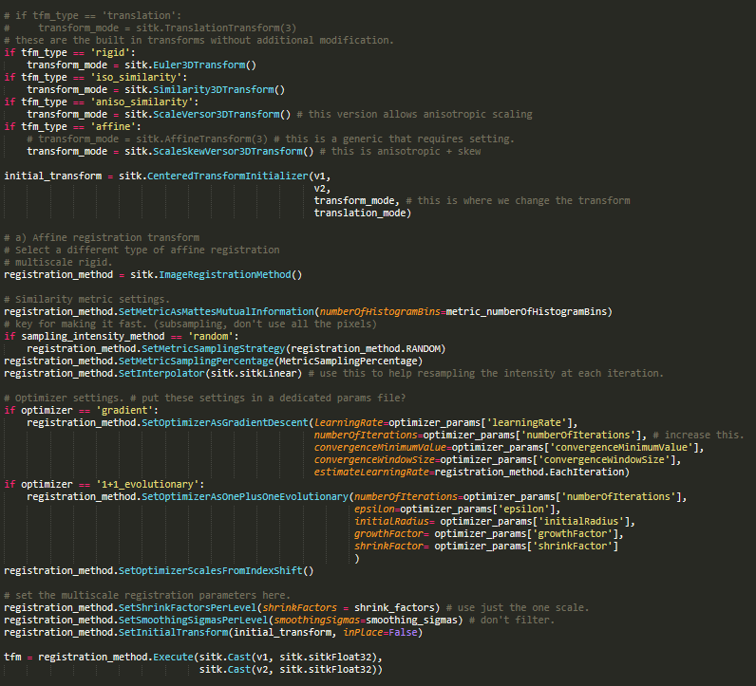 

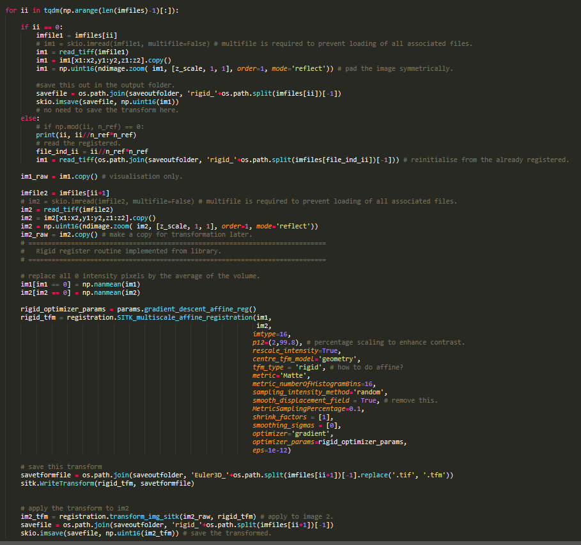

Non-rigid demons registration function modified from SimpleITK

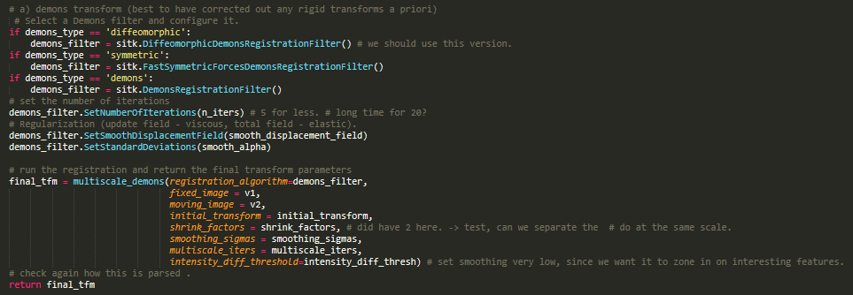

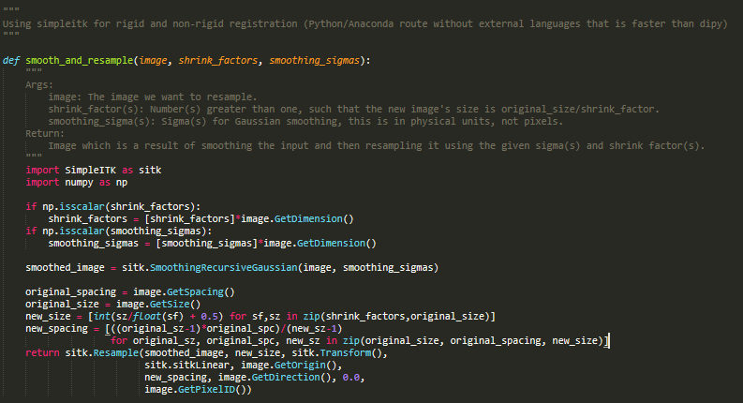 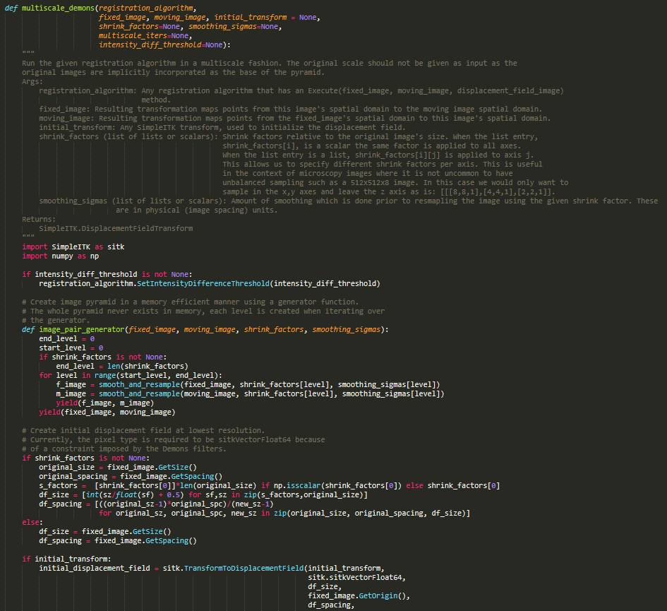 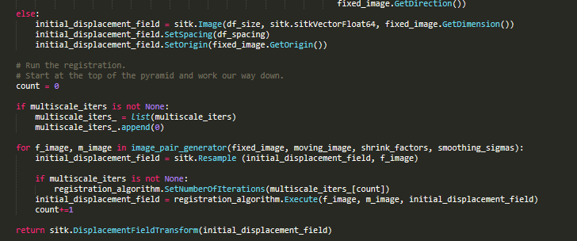

The function for warping given a transform (rigid or non-rigid)

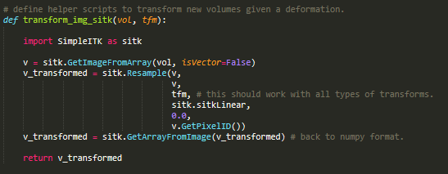

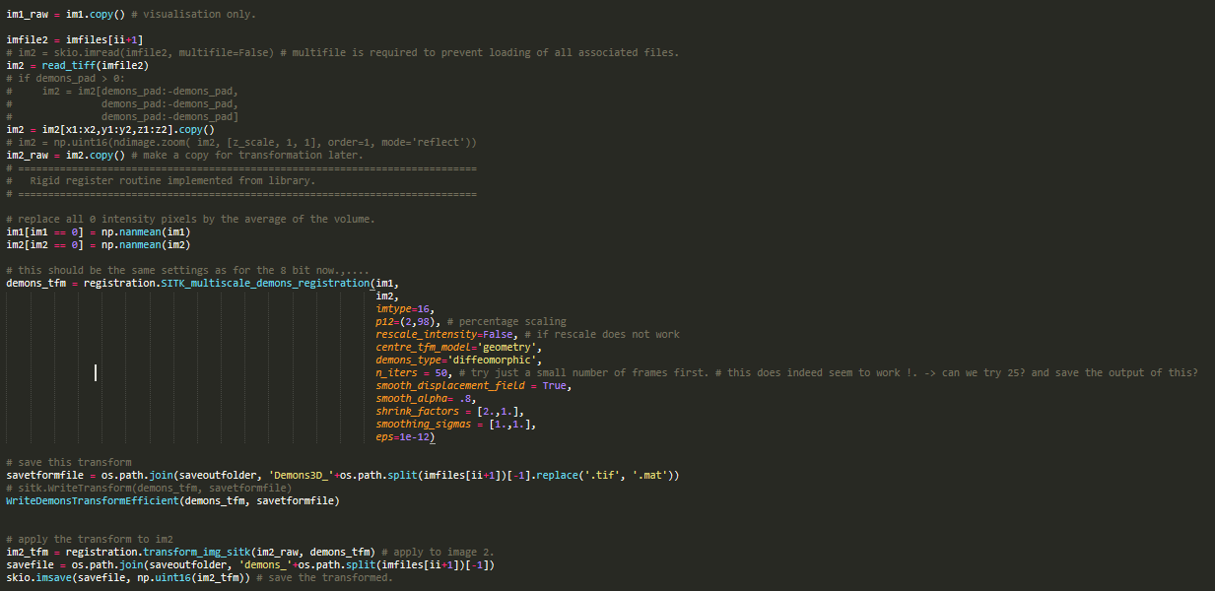

Reconstruction of the vertices from the demons displacement fields for each time point

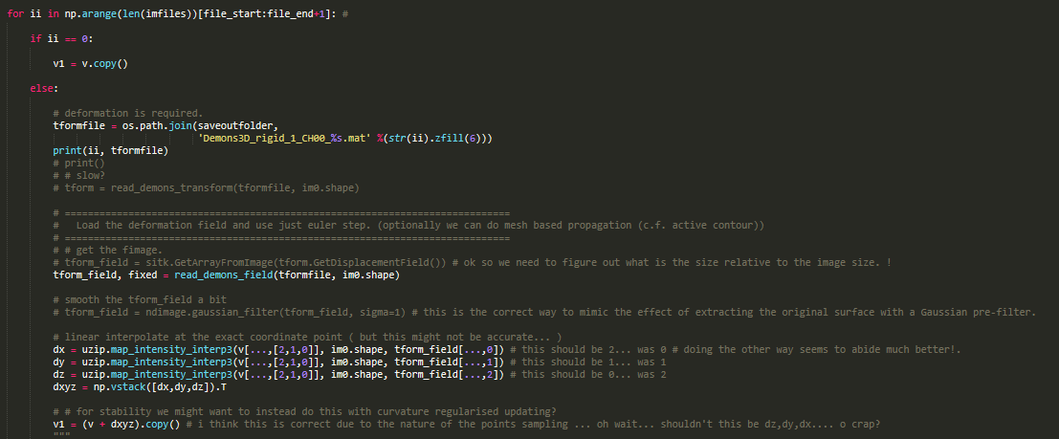

1. **Binary Segmentation and mesh creation**

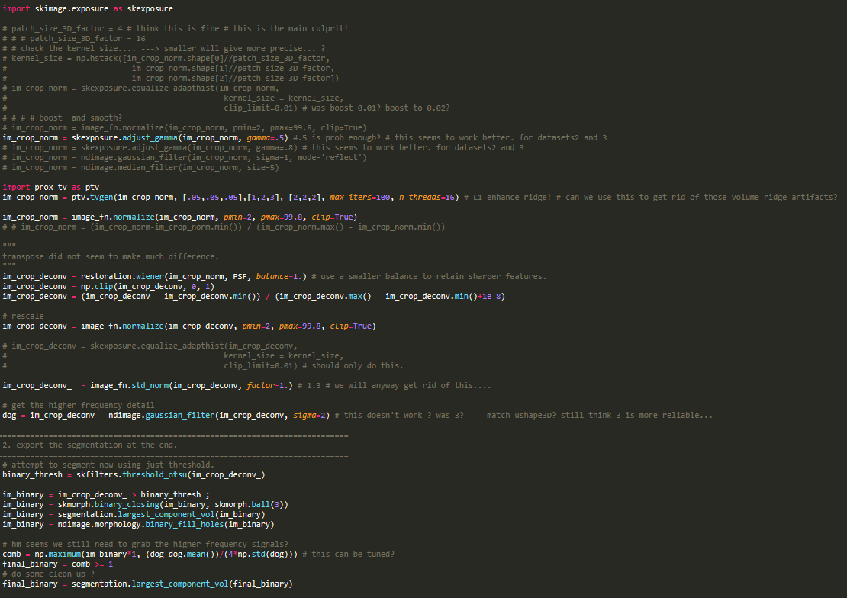

Restoration is skimage.restoration library. Restoration.wiener was extended to allow 3-d deconvolution. PSF was that of meSPIF made available in uShape3D publication.

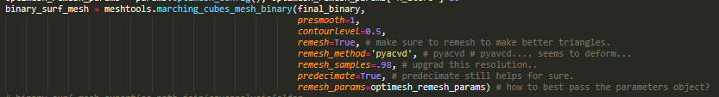

Modified marching cubes which runs skimage marching cubes after Gaussian smoothing with sigma=1, and then uses pyacvd to remesh equitriangly to 98% of the original vertices

1. **Curvature / Intensity measurement**

Code for measuring mesh curvature for vertex

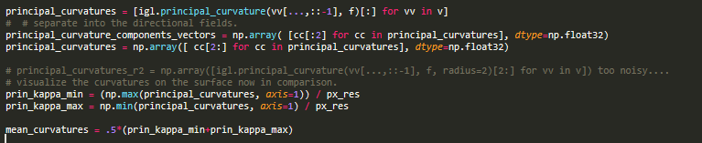

Code for steepest gradient descent into cell i.e.

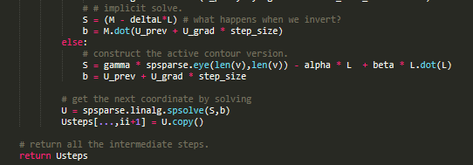

For external edge gradient computation use gradient of signed distance transform

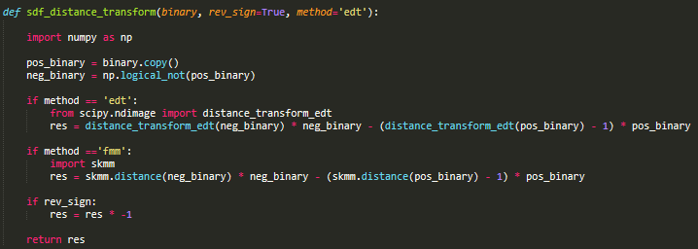

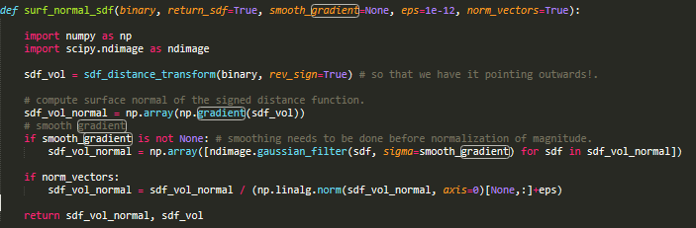

Intensity measurement (actual computation of raw intensity values)

Binary voxelisation of the mesh into a binary and then taking the mean for the volumetric intensity for normalization.

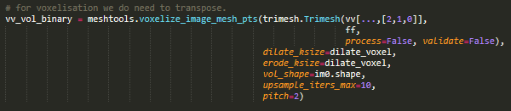



Setting the 1um distance





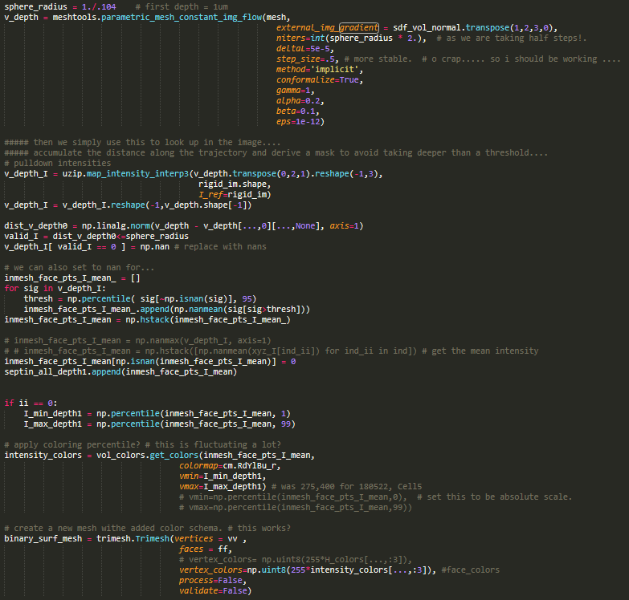

Actual sampling for a single timepoint.

1. **Bleach correction**



1. **Spatial mesh smoothing of timeseries**

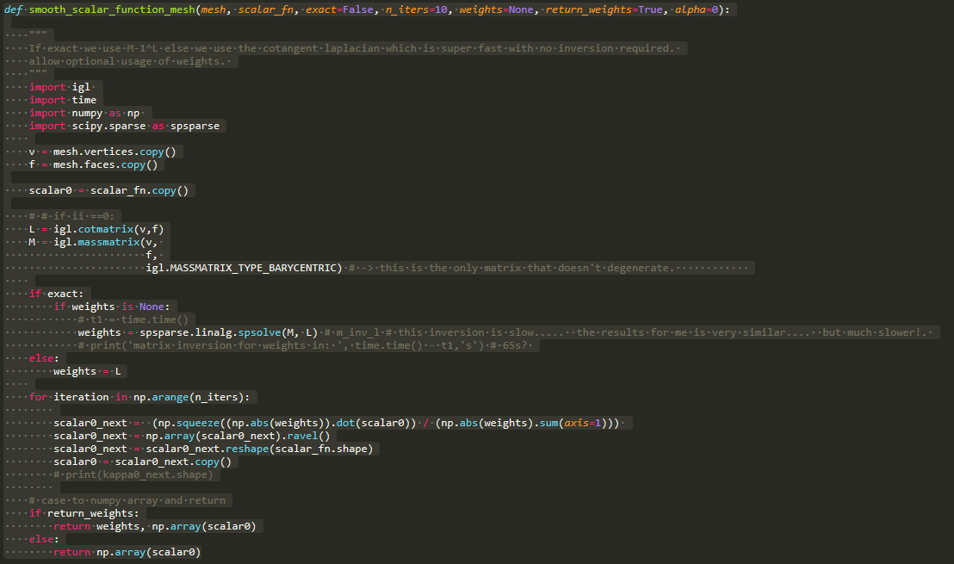

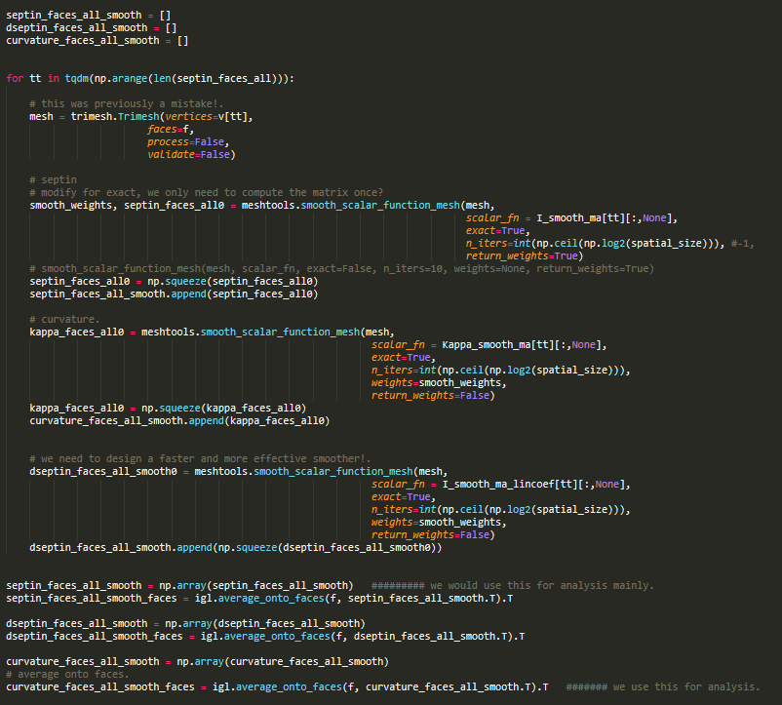

1. **Autocorrelation determination**

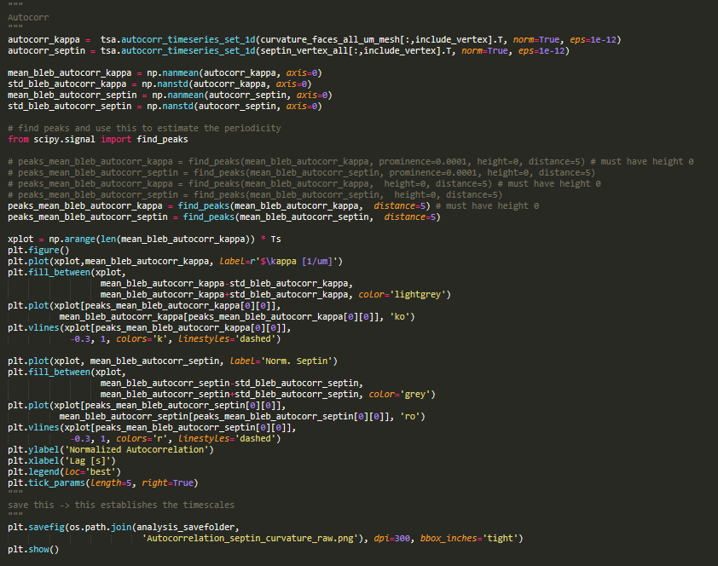

1. **Spatial correlation determination**

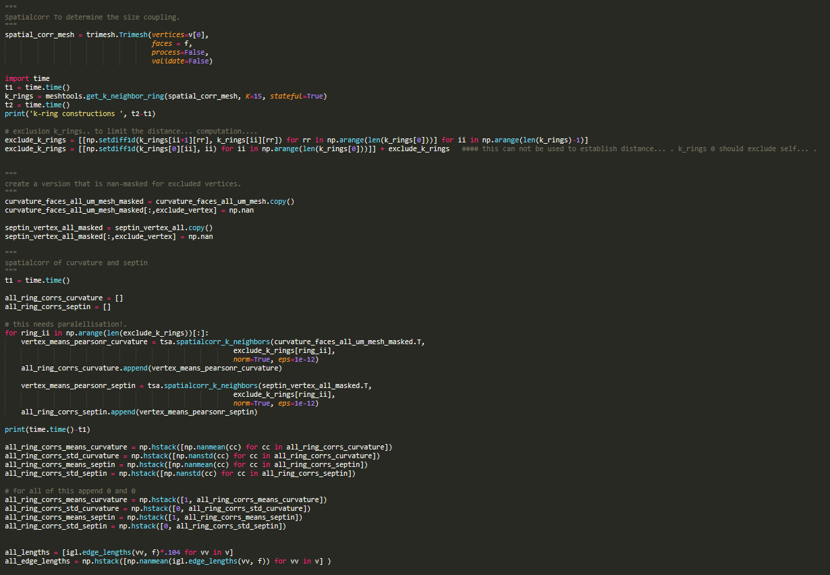

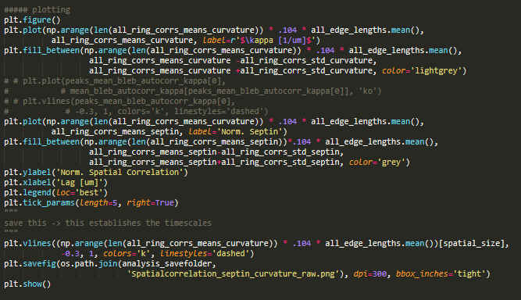

**Utility functions:**

Converting vertex timeseries to face timeseries (igl.average_onto_faces)